Git and GitHub Assignment

Assignment 1: Git Basics (Local Repository)
Objective:
To create a local Git repository and track project changes.

Steps and Commands
- mkdir student-management-system
- cd student-management-system
- git init
- nano README.md
- git status
- git add README.md
- git commit -m "Initial commit with README"
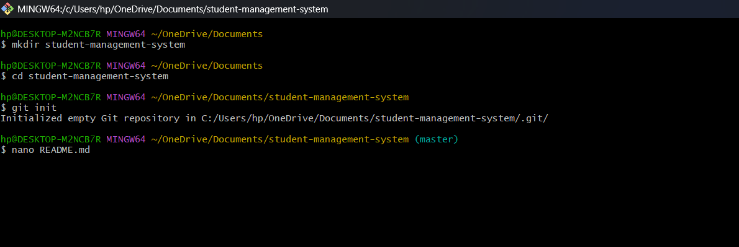

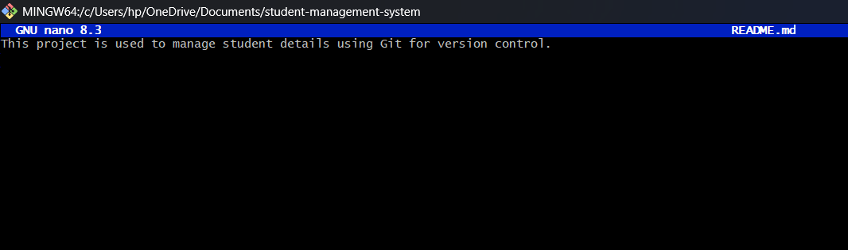
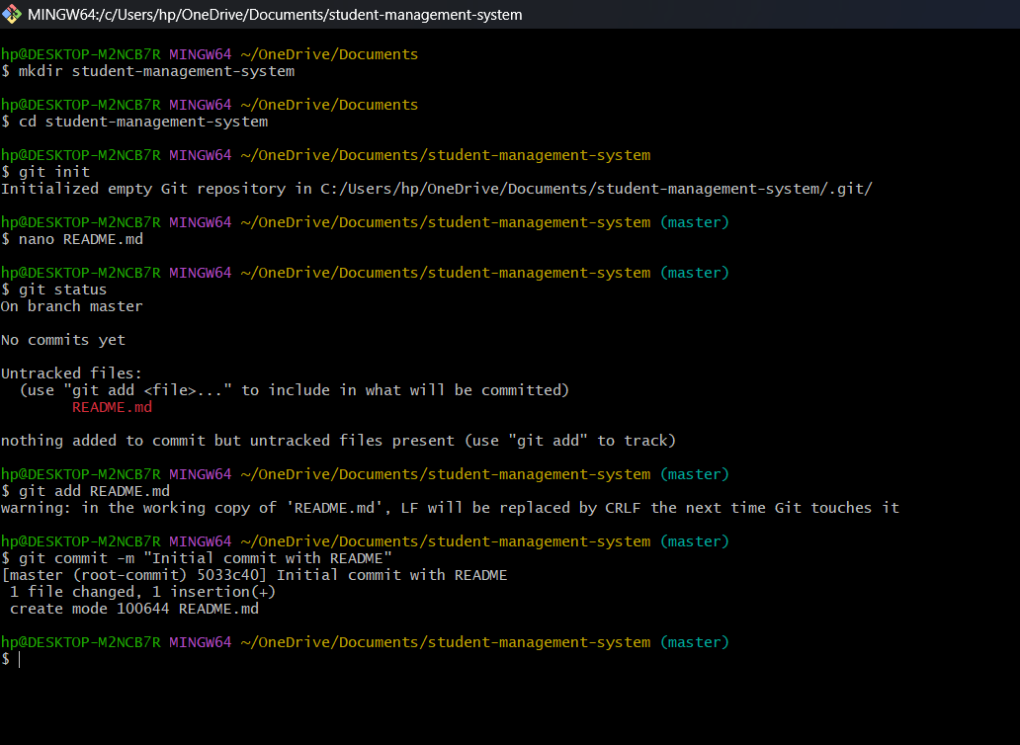

Assignment 2: Working with Branches
Objective:
To work with branches and merge changes into main branch.

Steps and Commands
- git branch feature-login
- git checkout feature-login
- touch login.txt
- git add login.txt
- git commit -m "Added login feature file"
- git checkout master
- git merge feature-login

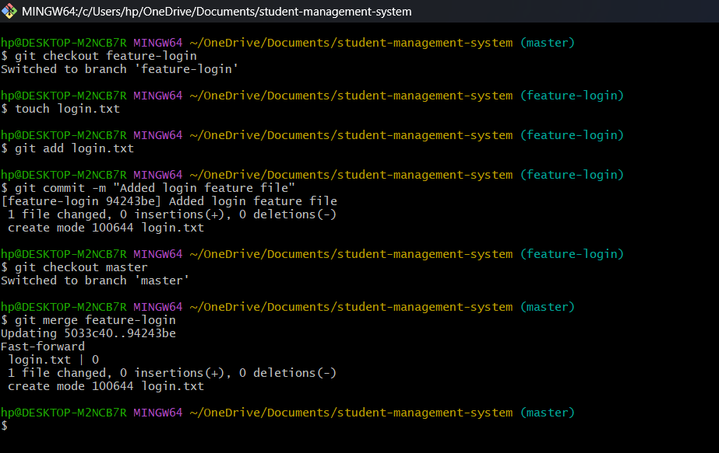

Assignment 3: GitHub Integration
Objective:
To connect local repository with GitHub and push code.

Steps and Commands
- git remote add origin https://github.com/Sanjay-Veeramalla/student-management-system
- git branch -M main
- git push –u origin main

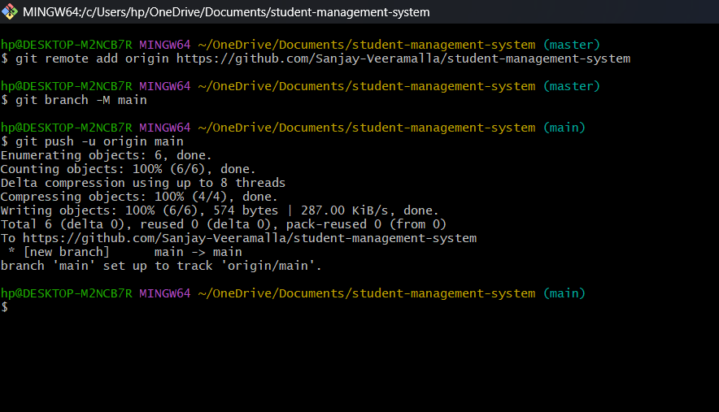

Assignment 4: GitHub Pull Request (PR)
Objective:
To demonstrate Pull Request workflow using GitHub.

Steps and Commands
- git checkout -b feature-update
- touch update.txt
- git add update.txt
- git commit -m "Added update file"
- git push origin feature-update
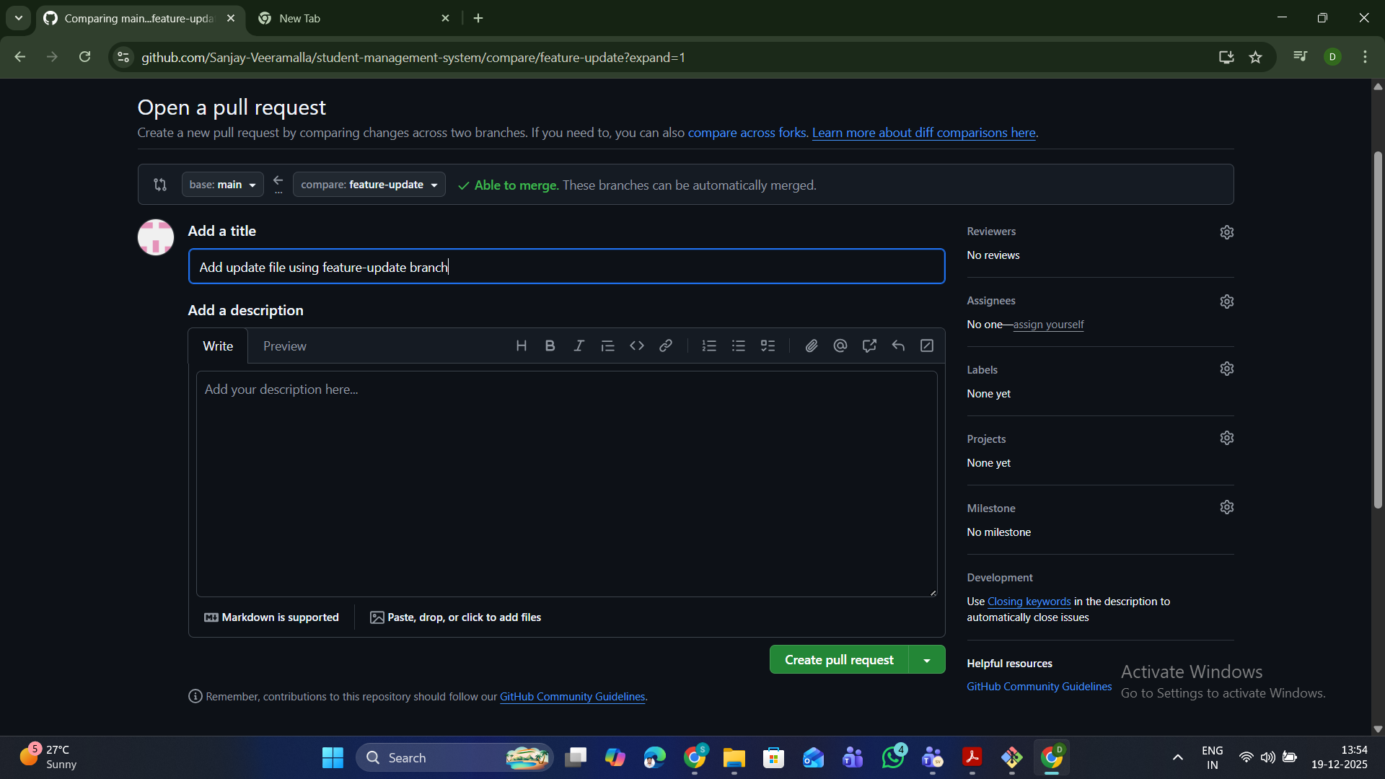
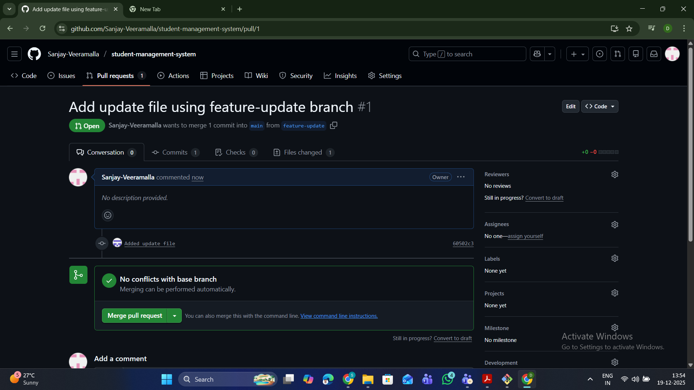

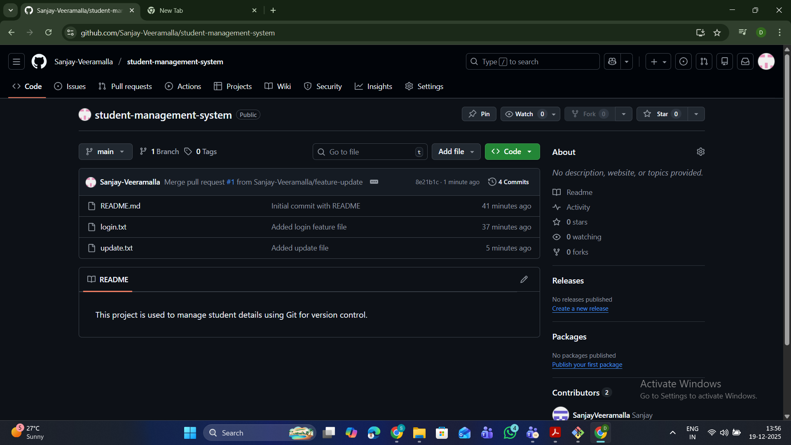

Conclusion
In this assignment, Git and GitHub concepts such as repository creation, branching, committing, pushing, and pull request workflow were successfully demonstrated.

